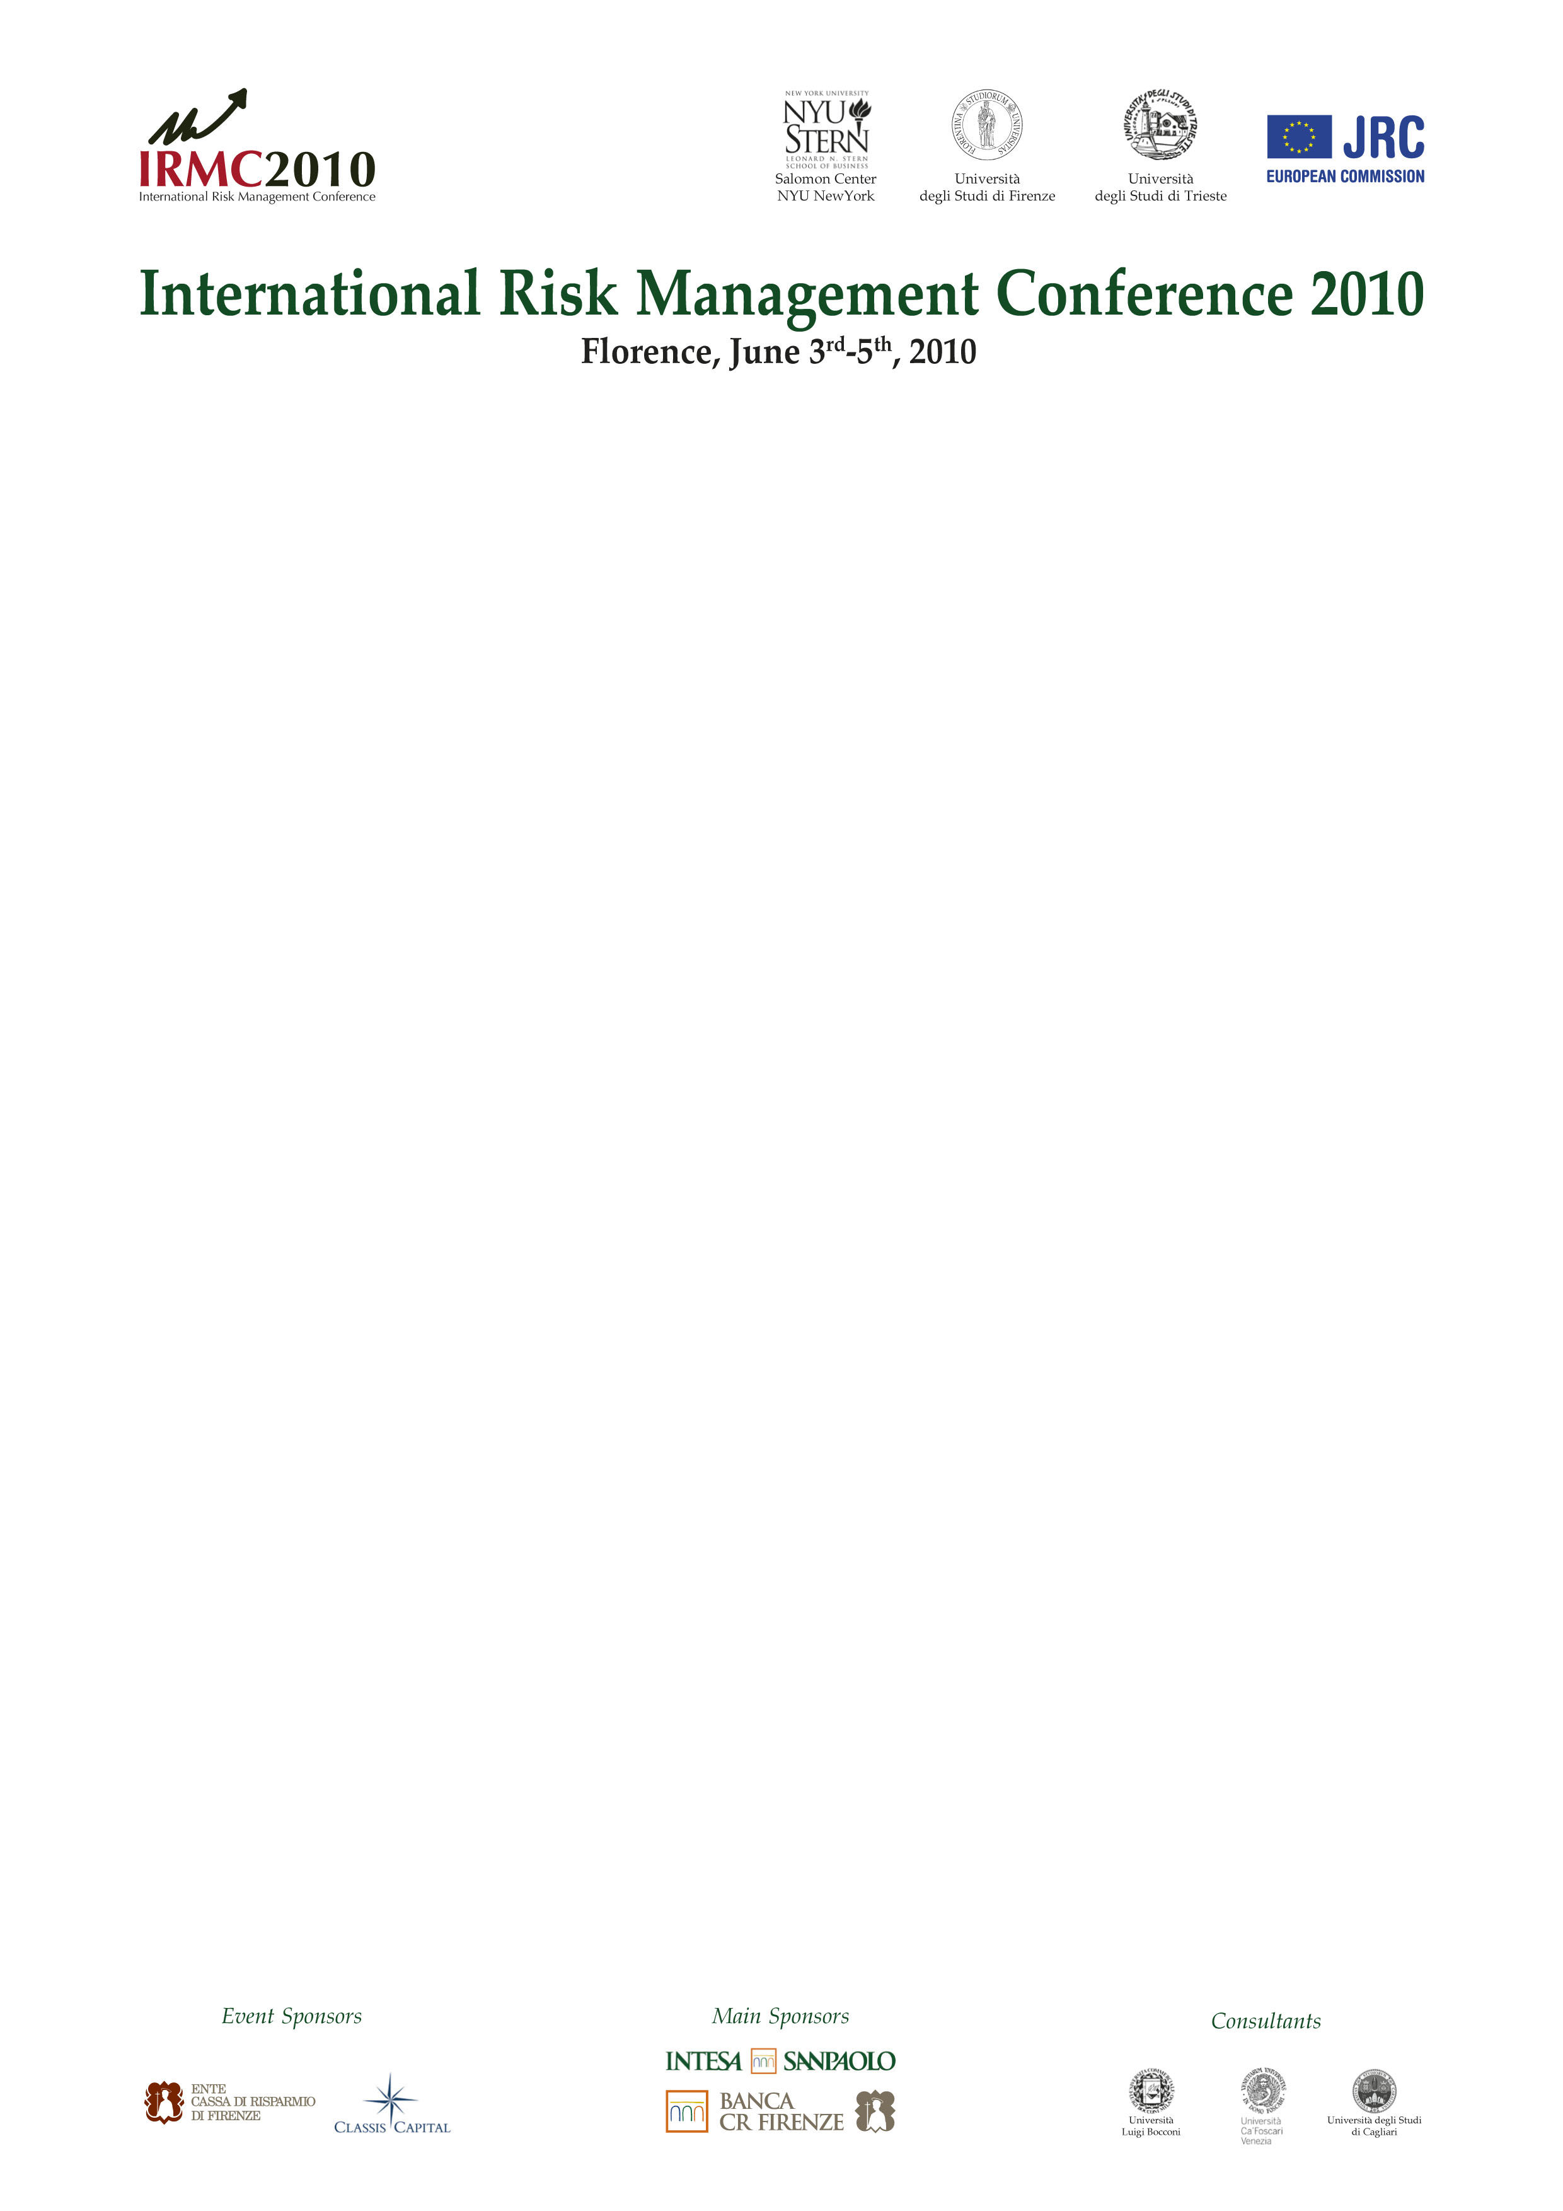

Accompanying Person Program

Friday, June 4th 2010 – 7 hours Florence walking guided tour

9:00 am: Meeting in front of the Savoy hotel with a IRMC sign
- 4 hours am
- Andrea del Castagno last supper, Museo di San Marco with Beato Angelico frescos inside the monk cells and Ghirlandaio last supper, & Palazzo Medici 1st residence of the Grand Dukes family,
- 3 hours pm
- Uffizi gallery + Caravaggio exibition

COST: € 50 per person with minimum 6 people plus entrance fees
- € 14 per person for Uffizi gallery (€ 4 only for EU nationalities over 65)
- € 6 per person for San Marco (free entrance for EU nationalities over 65)
- € 6 per person for Palazzo Medici

Saturday, June 5th 2010
Option 1 - Tour Uffizi + Caravaggio exhibition

2 pm meeting at the Gate n 1 of the Uffizi Gallery with a IRMC sign
- 1 hour tour Uffizi
- 1 hour Caravaggio exibition

COST: € 20 per person plus 14 euros per person for entrance ticket with reservation fee to avoid lines included

Option 2 – Chianti & San Gimignano 8 hours tour

2 pm pick up at Santa Maria Novella hotel, back 10 pm
COST: € 75 per person minimum 4 people
private van + driver & licensed guide, high tech microphone and license to enter in all traffic limited area of the city center.

Itinerary:
- Drive through the 13th century Romana gate towards Impruneta, known for its terracotta production, reach the 222 Chiantigiana road, stop in Greve in Chianti known for its old market square, visit a winery with tour and tasting, stop in Panzano in Chianti and taste some of the delicatessen of the local Dario Cecchini butcher, we drive than to San Gimignano and we discover the medieval village off the tourist track , late afternoon when all the big crowd has already left and we walk along the walls.
Dinner & entrance fees Not included.

For information and booking please contact:

Florence Tour by Paola Migliorini
Via San Gallo 120 - 50129 Firenze, Italy
www.florencetour.com
info@florencetour.com
Tel & Fax +39 Italy Code 055472448
Mobile +39 Italy Code 3476572611 Paola
Mobile +39 Italy Code 3473760897 Giuseppe

